Ben Cimini, Blair Bowen, Caleb Hendrix

ciminibb@mail.uc.edu, bowenbv@mail.uc.edu, hendricw@mail.uc.edu

Abstract

Our project applies cloud computing, data engineering, and data science skills to a retail dataset from 84.51°. We leverage tools and services from Azure to derive insights that could, feasibly, enhance the retail experience for customers.

GROUP 39 Final Project

Data Science and Analytics Using Azure Cloud Computing Technologies

# Write-Up on ML Models

**Linear Regression**

Linear Regression is among the simplest ML models. It assumes a linear relationship between input and output variables, classically represented by $y=mx+b$. In the context of regression modeling, $b$ and $m$ are sometimes called $β_{0}$ and $β_{1}$ respectively. The goal of such modeling is to find the best values of $β_{0}$ and $β_{1}$, by minimization of error in the best-fit line.

**Random Forest**

Random Forest is popular and powerful. It is based on statistical bagging, in which repeated samples are taken from a dataset to yield many decision trees. When a prediction is needed, the result of each decision tree is averaged for a strong estimate. Random Forest introduces randomness into these decision trees, meaning they’re more different from one another than they would be otherwise.

**Gradient Boosting**

Gradient Boosting is powerful but dense. It also uses decision trees, but they depend on one another. Unlike Random Forest, each tree in Gradient Boosting is based on the last in an attempt to fix errors. Ultimately, it aims to create a “strong learner” from the “weak learner” trees. The number of weak learners depends on the dataset. They will keep being iterated upon until a) the training set is predicted perfectly or b) some maximum number of decision trees have been exhausted. The final prediction is a weighted average over the trees.

**Conclusion**

Any of the above would be serviceable for Basket Analysis, at least. So, a choice between them becomes one of explainability versus predictive accuracy. In short, given the nature of this project and dataset, we believe Random Forest is our best, most balanced choice.

# Web Server Setup

Created a resource group for this project, <finalproject-group39-rg-1>, and gave the “Owner” role to all members.

Created a Linux VM for the web server, <finalproject-group39-vm-webserver>, using defaults from the “Free Services” page.

Added inbound security rules for HTTP and HTTPS, making the VM internet accessible.

Updated the VM’s package list before necessary installations.

Installed Python 3 and pip on the VM.

Installed Flask on the VM.

Created a Flask app on the VM to expose our data to the internet. At this point, the app only displayed a message.

This is the message the app displayed at the time of writing.

Added to the Flask app so it has a sign-in form on the homepage that, upon submission, redirects the user to a menu. You can see the relevant screenshots below (note that the menu shown is an early version). For the code and file structure involved, visit our repository. A screenshot of a computer

# Datastore and Data Loading

Created a storage account and container, <finalprojectgroup39sa> and <8451-data> respectively, since Azure SQL Database does not allow direct uploads, meaning we need blob storage. 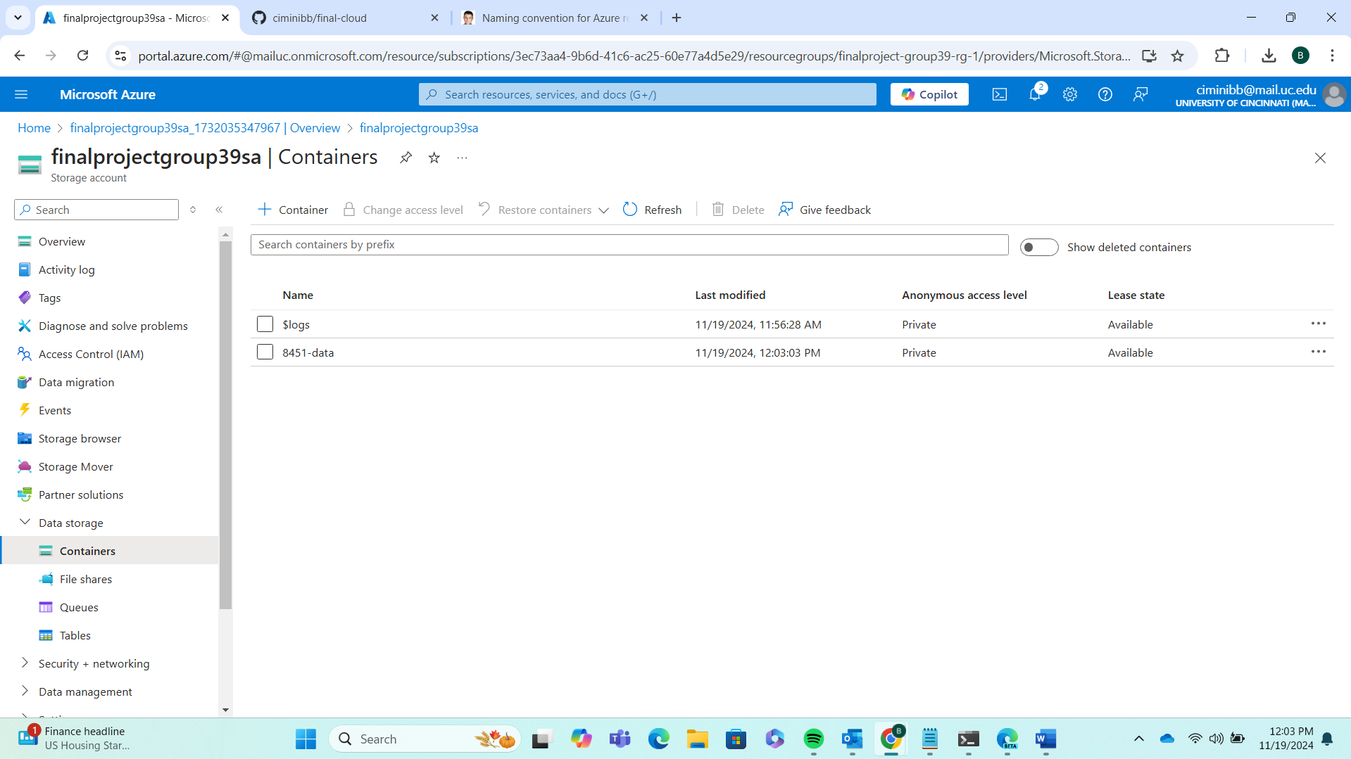

Uploaded 84.51° retail data to the blob storage container. 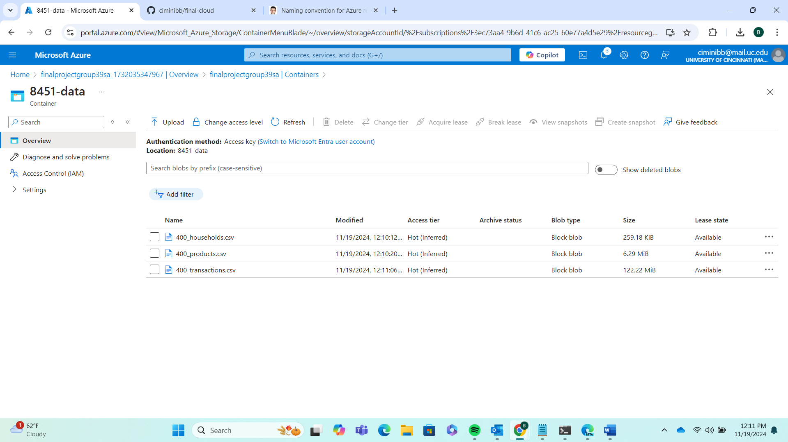

Created a SQL database and associated server, <finalproject-group39-sql-db> and <finalproject-group39-sql-server> respectively, to which the 84.51° retail data will be fed. A computer screen shot of a computer

Added a firewall rule to the database that lets our VM, <finalproject-group39-vm-webserver>, access the database. Thus allowing its data to be pulled into the Flask app.

Created all necessary database tables – Households, Products, and Transactions – in Azure Data Studio. The schemas were defined per the SQL queries below to mimic those of the CSV files. A screenshot of a computer

Cleaned the CSVs of problematic extra whitespace then created a data factory, linked services for blob storage and database, and a dataset for each CSV file and database table. These were then incorporated into an end-to-end data pipeline that copied the CSVs to our SQL database in one swoop. This was the longest step of the project so far and took lots of debugging. The whitespace issue, for example, was difficult to discover.A computer screen shot of a computer

Wrote a query for the sample data pull (Household 10) whose results will be displayed in the Flask app.

Integrated the query above into our Flask app, creating a display page for the data pull. Again, this was a rather long process. Rather than explain it here, I’ll, once again, leave you to review the code in our GitHub repository. The resulting display page looked like this. A screenshot of a computer

# Interactive Web Page

# Data Loading Web App

# Web Page with Dashboard

# ML Model Application

# Churn Prediction